Asymptotic Notation
What is Asymptotic Notation?
Whenever we want to perform analysis of an algorithm, we need to calculate the complexity of that algorithm. But when we calculate complexity of an algorithm it does not provide the exact amount of resource required. So instead of taking an exact amount of resource we represent that complexity in a general form (Notation) which produces the basic nature of that algorithm. We use that general form (Notation) for the analysis process.
Asymptotic notation of an algorithm is a mathematical representation of its complexity
For example, consider the following time complexities of two algorithms...
- Algorihtm 1 : 5n² + 2n + 1
- Algorihtm 2 : 10n² + 8n + 3
Generally, when we analyze an algorithm, we consider the time complexity for larger values of input data (i.e. 'n' value). In the above two time complexities, for larger value of 'n' the term in algorithm 1 '2n + 1' has less significance than the term '5n²', and the term in algorithm 2 '8n + 3' has less significance than the term '10n²'.
Here for larger values of 'n' the value of most significant terms ( 5n² and 10n² ) is very larger than the value of least significant terms ( 2n + 1 and 8n + 3 ). So for larger values of 'n' we ignore the least significant terms to represent overall time required by an algorithm. In asymptotic notation, we use only the most significant terms to represent the time complexity of an algorithm.
Majorly, we use THREE types of Asymptotic Notations and those are as follows...
- Big - Oh (O)
- Big - Omega (Ω)
- Big - Theta (Θ)

Big - Oh Notation (O)
Big - Oh notation is used to define the upper bound of an algorithm in terms of Time Complexity.
That means Big - Oh notation always indicates the maximum time required by an algorithm for all input values. That means Big - Oh notation describes the worst case of an algorithm time complexity.
Big - Oh Notation can be defined as follows...
Consider function f(n) the time complexity of an algorithm and g(n) is the most significant term.
If f(n) <= C g(n) for all n >= n₀, C > 0 and n₀ >= 1. Then we can represent f(n) as O(g(n)).
f(n) = O(g(n))
Consider the following graph drawn for the values of f(n) and C g(n) for input (n) value on X-Axis and time required is on Y-Axis
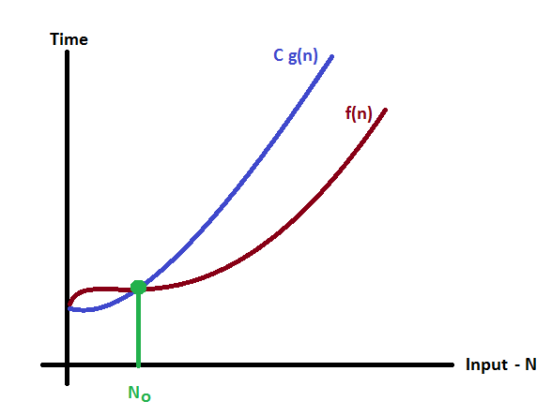
In the above graph after a particular input value n₀, always C g(n) is greater than f(n) which indicates the algorithm's upper bound.

Example
Consider the following f(n) and g(n)...
f(n) = 3n + 2
g(n) = n
If we want to represent f(n) as O(g(n)) then it must satisfy f(n) <= C g(n) for all values of C > 0 and n₀>= 1
f(n) <= C g(n)
⇒3n + 2 <= C n
The above condition is always TRUE for all values of C = 4 and n >= 2.
By using Big - Oh notation we can represent the time complexity as follows...
3n + 2 = O(n)
Big - Omega Notation (Ω)
Big - Omega notation is used to define the lower bound of an algorithm in terms of Time Complexity.
That means Big - Omega notation always indicates the minimum time required by an algorithm for all input values. That means Big - Omega notation describes the best case of an algorithm time complexity.
Big - Omega Notation can be defined as follows...
Consider function f(n) the time complexity of an algorithm and g(n) is the most significant term. If f(n) >= C g(n) for all n >= n₀, C > 0 and n₀ >= 1. Then we can represent f(n) as Ω(g(n)).
f(n) = Ω(g(n))
Consider the following graph drawn for the values of f(n) and C g(n) for input (n) value on X-Axis and time required is on Y-Axis
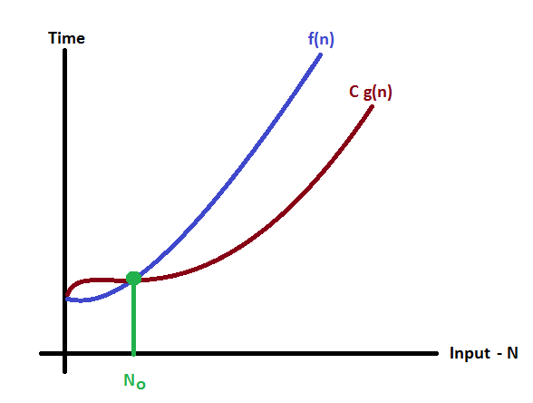
In the above graph after a particular input value n₀, always C x g(n) is less than f(n) which indicates the algorithm's lower bound.
Example
Consider the following f(n) and g(n)...
f(n) = 3n + 2
g(n) = n
If we want to represent f(n) as Ω(g(n)) then it must satisfy f(n) >= C g(n) for all values of C > 0 and n₀>= 1
f(n) >= C g(n)
⇒3n + 2 >= C n
The above condition is always TRUE for all values of C = 1 and n >= 1.
By using Big - Omega notation we can represent the time complexity as follows...
3n + 2 = Ω(n)
Big - Theta Notation (Θ)
Big - Theta notation is used to define the average bound of an algorithm in terms of Time Complexity.
That means Big - Theta notation always indicates the average time required by an algorithm for all input values. That means Big - Theta notation describes the average case of an algorithm time complexity.
Big - Theta Notation can be defined as follows...
Consider function f(n) the time complexity of an algorithm and g(n) is the most significant term.
If C₁ g(n) <= f(n) <= C₂ g(n) for all n >= n₀, C₁, C₂ > 0 and n₀ >= 1. Then we can represent f(n) as Θ(g(n)).
f(n) = Θ(g(n))
Consider the following graph drawn for the values of f(n) and C g(n) for input (n) value on X-Axis and time required is on Y-Axis
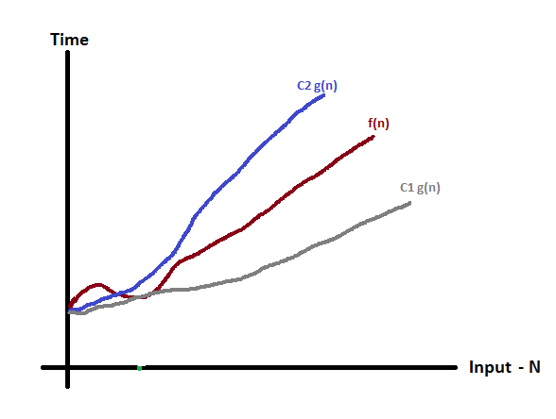
In the above graph after a particular input value n₀, always C₁ g(n) is less than f(n) and C₂ g(n) is greater than f(n) which indicates the algorithm's average bound.
Example
Consider the following f(n) and g(n)...
f(n) = 3n + 2
g(n) = n
If we want to represent f(n) as Θ(g(n)) then it must satisfy C₁ g(n) <= f(n) <= C₂ g(n) for all values of C₁, C₂ > 0 and n₀>= 1
C₁ g(n) <= f(n) <= C₂ g(n)
C₁ n <= 3n + 2 <= C₂ n
The above condition is always TRUE for all values of C₁ = 1, C₂ = 4 and n >= 1.
By using Big - Theta notation we can represent the time complexity as follows...
3n + 2 = Θ(n)

